**User Manual of Acts Details Page**

There two forms in Acts Details:

**Acts Form:**

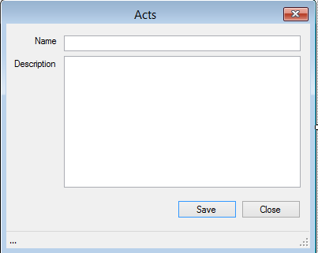

* **This is an act form where the different acts related to the cases can be stored.**

**Acts List Form:**

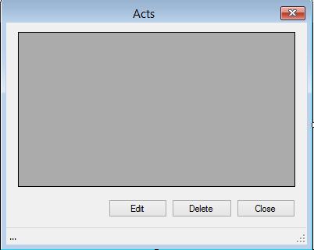

* **This is an Acts List Form where user can view, edit and delete the lists of acts of releted cases.**